Q. WRITE A PROGRAM TO DISPLAY THE TYPESOF ARITHMETIC PROMOTIONS.

1. . #include <stdio.h>

int main()

{

int a=250;

char ch='S';//this character converts itself into ASCII code integer

printf("%d",a+ch);

return 0;

}

2. . #include<stdio.h>

int main()

{

char ch1='J';//Conversion of character into ASCII code integer

char ch2='s';//Conversion of character into ASCII code integer

printf("%d",ch1+ch2);

return 0;

}

OUTPUT:

1.

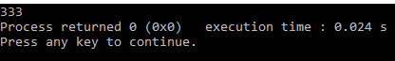

2.

